MySQL Master Slave Replication configuration

Prerequisites
To set up a MySQL master slave replication, you need to have the following:
- 2 VM (Virtual Machine) or VPS (Virtual Private Server) with root access.
- Working Internet.

Steps to Achieve MySQL Master Slave Replication
For this demo purpose, you will be calling master as root@repl-master and slave as root@repl-slave.
For this demo, let’s assume the IP address for the master and slave are as follows:
Master server: 12.34.56.111
Slave server: 12.23.34.222

1. Setting Up The Master
The first thing you need to accomplish in the replication process is to install and configure the master server. If you have not installed MySQL, then you can install MySQL using the following command:
root@repl-master:~# sudo apt-get update
root@repl-master:~# sudo apt-get install mysql-server mysql-client -y
root@repl-master:~# sudo mysql_secure_installation

Once the MySQL installation process is completed, use the following command to edit the MySQL configuration file:
root@repl-master:~# sudo nano /etc/mysql/mysql.conf.d/mysqld.cnf

[mysqld]
server-id = 1
pid-file = /var/run/mysqld/mysqld.pid
socket = /var/run/mysqld/mysqld.sock
datadir = /var/lib/mysql
bind-address = 12.34.56.111
binlog_format = ROW
log_error = /var/log/mysql/error.log
log_bin = /var/log/mysql/mysql-bin.log
log_bin_index = /var/log/mysql/mysql-bin.log.index
max_binlog_size = 500M
slow_query_log = 1
relay_log = /var/log/mysql/mysql-relay-bin
relay_log_index = /var/log/mysql/mysql-relay-bin.index
Restart MySQL service using the following command:
root@repl-master:~# sudo service mysql restart

2. Create A New User For Slave
The next step is to create a new user for your slave server. Use the following command to create it:
root@repl-master:~# mysql -uroot -p;
mysql> CREATE USER ‘slave’@’12.34.56.789‘ IDENTIFIED BY ‘SLAVE_PASSWORD‘;
mysql> GRANT REPLICATION SLAVE ON *.* TO ‘slave’@’ ’12.34.56.789’;
mysql> FLUSH PRIVILEGES;

mysql> FLUSH TABLES WITH READ LOCK; (This used only when you send all data master to slave, during transformation lock is used.)
here user host id must be give to slave host
You will use the following command to know the current status of the master server:
mysql> SHOW MASTER STATUS;
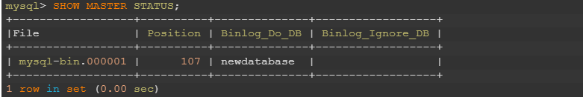
This command will also tell the slave to follow the master from this position.

3. Move Data From Master To Slave
Now that you have marked the position, you can start moving the data from the master to the slave. You need to create a MySQL dump file to move the data. Use the following command to create the dump file:
root@repl-master:~# mysqldump -u root -p --single-transaction --routines --triggers --events --all-databases > data.sql
To copy the dump file to the slave, use the following command:
scp data.sql root@12.34.56.222
Unlock the tables using the following command:
mysql> UNLOCK TABLES;

4. Configure Slave Server
Now, all you need to do is configure the slave server and test if replication is working. Ensure MySQL is installed.
Open the configuration file in your slave server and update these lines:
root@repl-slave:~# sudo nano /etc/mysql/mysql.conf.d/mysqld.cnf

In the same way that you did for the master server, you need to bind the IP address and uncomment those two lines for the slave server.
Also configure following parameter.
server-id = 2
relay-log = /var/log/mysql/mysql-relay-bin.log
log_bin = /var/log/mysql/mysql-bin.log
pid-file = /var/run/mysqld/mysqld.pid
socket = /var/run/mysqld/mysqld.sock
bind-address = 12.23.34.222
datadir = /var/lib/mysql
max_binlog_size = 500M
slow_query_log = 1
Now, restart the MySQL server using the following command:
root@repl-slave:~# sudo service mysql restart

5. Import Data Dump
Use the following command to import the dump file to the slave server:
root@repl-slave:~# mysql -uroot -p < data.sql

The next step is to enable the replication from within the MySQL shell.
Run the following command to allow the slave server to replicate the Master server: (run below command on slave side)
Mysql > CHANGE MASTER TO MASTER_HOST='your_master_ip’, MASTER_USER='slave_user', MASTER_PASSWORD='password', MASTER_LOG_FILE='mysql-bin.000001', MASTER_LOG_POS= 107;
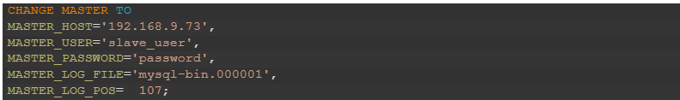
Once the data is imported, you need to stop MySQL in the slave server using the following command:
root@repl-slave:~# mysql -uroot -p;
mysql> STOP SLAVE;
You have finally imported the dump files and updated the master IP address, password, log file name, and position, to enable the master to communicate with the slave without any issues.

6. Start Slave Server
Next, use the “Start Slave” command to start operating the slave server.
START SLAVE;

7. Test MySQL Master Slave Replication
To test if your MySQL master slave replication works, just create a database in your master server and see if it is replicated in the slave server. If you can see the database in the slave, then it is working fine.
Create a test database in a master server called ‘sampledb’.
CREATE DATABASE sampledb;
Now login to your slave server and list the databases, and if you see the “sampledb” there, then the master slave replication process is working fine.
Login to your slave server and use the following command to list all databases:
show databases;

firewall-cmd --add-port=3306 --permanent

Last_IO_Errno: 2061
Last_IO_Error: error connecting to master 'replicator@localhost:3306' - retry-time: 60 retries: 1 message: Authentication plugin 'caching_sha2_password' reported error: Authentication requires secure connection.

Solution at master side :-
mysql> CHANGE MASTER TO GET_MASTER_PUBLIC_KEY=1;

